The 67 Throws of Kodokan Judo
Dai Ikkyo (1st group) | Dai Nikyo (2nd group)
1. Deashi Harai (Forward Foot Sweep) | 1. Kosoto Gari (Small Outside Reap)
2. Hiza Guruma (Knee Wheel) | 2. Kouchi Gari (Small Inner Reap)
3. Sasae Tsurikomi Ashi (Lifting Pulling Ankle Block) | 3. Koshi Guruma (Hip Wheel)
4. Uki Goshi (Floating hip) | 4. Tsurikomi Goshi (Lifting Pulling Hip)
5. Osoto Gari (Large Outer Reaping) | 5. Okuriashi Harai (Following Foot Sweep)
6. O Goshi (Large Hip Throw) | 6. Tai Otoshi (Body Drop)
7. Ouchi Gari (Large Inner Reaping) | 7. Harai Goshi (Sweeping Hip Throw)
8. Seoi Nage (Sholder Throw, Morote, Ippon) | 8. Uchi Mata (Inner Tigh Throw)
Sankyo (3rd group) | Yonkyo (4th group)
1. Kosoto Gake (Small Outside Hook) | 1. Sumi Gaeshi (Corner Reversal)
2. Tsuri Goshi (Lifting Hip) | 2. Tani Otoshi (Valley Drop)
3. Yoko Otoshi (Side Drop) | 3. Hane Makikomi (Spring-Wrap Around Throw)
4. Ashi Guruma (Leg Wheel) | 4. Sukui Nage (Scoop Throw)
5. Hane Goshi (Spring Hip Throw) | 5. Utsuri Goshi (Changing Hip Throw)
6. Harai Tsurikomi Ashi (Lifting Pulling Foot Sweep) | 6. O Guruma (Large Wheel)
7. Tomoe Nage (Circle Throw) | 7. Soto Makikomi (Outer Wrap Around)
8. Kata Guruma (Shoulder Wheel) | 8. Uki Otoshi (Floating Drop)
Gokyo (5th group) | Habukareta Waza (preserved techniques from 1895 gokyo)
1. Osoto Guruma (Large Outer Wheel) | 1. Obi Otoshi (Belt Drop) *
2. Uki Waza (Floating Technique) * | 2. Seoi Otoshi (Sholder throw, Spread leg version)
3. Yoko Wakare (Side Separation) | 3. Yama Arashi (Mountain Storm) *
4. Yoko Guruma (Side Wheel) | 4. Osoto Otoshi (Large Outer Drop)
5. Ushiro Goshi (Rear Hip Throw) | 5. Daki Wakare (High Lift And Separate) *
6. Ura Nage (Rear Throw) | 6. Hikikomi Gaeshi (Pulling In Reversal) *
7. Sumi Otoshi (Corner Drop) | 7. Tawara Gaeshi (Rice Bale Reversal) *
8. Yoko Gake (Side Hook) | 8. Uchi Makikomi (Inner Wraparound) *
Shinmeisho No Waza (newly accepted techniques)
1. Morote Gari (Two Hand Reap) | 2. Kuchiki Taoshi (Single Leg Takedown)
3. Kibisu Gaeshi (Heel Trip Reversal) | 4. Uchi Mata Sukashi (Inner Tigh Reaping Throw Slip)*
5. Daki Age (High Lift) * | 6. Tsubame Gaeshi (Swallovs Flight Reversal) *
7. Kouchi Gaeshi (Minor Inner Reap Reversal counter) * | 8. Ouchi Gaeshi (Large Inner Reaping Throw Counter) *
9. Osoto Gaeshi (Large Outer Reaping Throw Counter) * | 10. Harai Goshi Gaeshi (Sweeping Hip Throw Counter)*
11. Uchi Mata Gaeshi (Inner Tigh Reaping Throw Counter) * | 12. Hane Goshi Gaeshi (Spring Hip Throw Counter) *
13. Kani Basami (Flying Scissors) * | 14. Osoto Makikomi (Major Outer Wrap Around) *
15. Kawazu Gake (One Leg Entanglement Drop) * | 16. Harai Makikomi (Sweeping Wraparound) *
17. Uchi Mata Makikomi (Inner Tigh Wrap Around) * | 18. Sode Tsurikomi Goshi (Sleeve Lifting Pulling Hip)
19. Ippon Seoinage (One Arm Shoulder Throw)

* Ingår i Kodakan men inte i vårt graderingshäfte

The 29 Official Grappling Techniques of Kodokan Judo
Osaekomi-waza (pins or matholds) | Shime-waza (chokes or strangles)
1. Kuzure-kesa-gatame | 1. Nami-juji-jime
2. Kata-gatame | 2. Gyaku-juji-jime
3. Kami-shiho-gatame | 3. Kata-juji-jime
4. Kuzure-kami-shiho-gatame * | 4. Hadaka-jime
5. Yoko-shiho-gatame * | 5. Okuri-eri-jime
6. Tate-shiho-gatame | 6. Kata-ha-jime
7. Kesa-gatame | 7. Do-jime *
 | 8. Sode-guruma-jime
 | 9. Kata-te-jime *
 | 10. Ryo-te-jime *
 | 11. Tsukkomi-jime
 | 12. Sankaku-jime

Kansetsu-waza (joint locks)
1. Ude-garami | 2. Ude-hishigi-juji-gatame
3. Ude-hishigi-ude-gatame | 4. Ude-hishigi-hiza-gatame
5. Ude-hishigi-waki-gatame | 6. Ude-hishigi-hara-gatame
7. Ashi-garami * | 8. Ude-hishigi-ashi-gatame *
9. Ude-hishigi-te-gatame * | 10. Ude-hishigi-sankaku-gatame *

Tekniker
Nage Wasa Kastteknik
Koshi-waza Kast - Höfttekniker
Te-wasa Kast - Handteknik
Masutemi-waza Kast - Offerteknik framåt
Ashi-waza Kast - Fottekniker
Osaekomi-waza Fasthållningsteknik
Kansetsu-waza Låsteknik
Yokosutemi-waza Offerkast åt sidan
Shime-waza Halslåsteknik
Ukemi-wasa Fallteknik
Kata Form “Arrangerad Judo”

* Ingår i Kodakan men inte i vårt graderingshäfte
Dai Ikkyo (1st group)
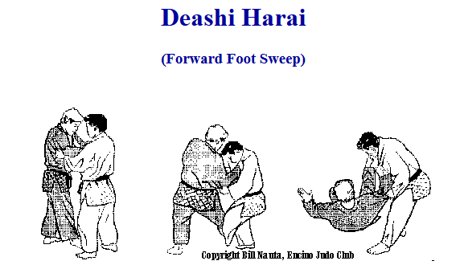 | 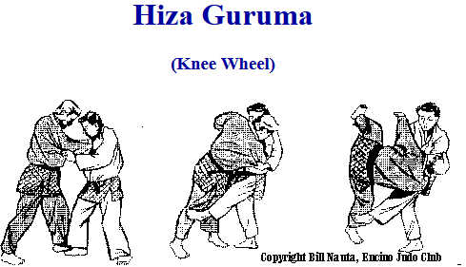
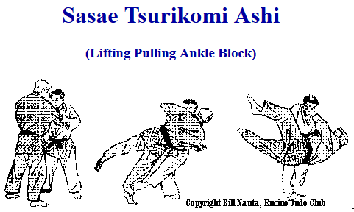 | 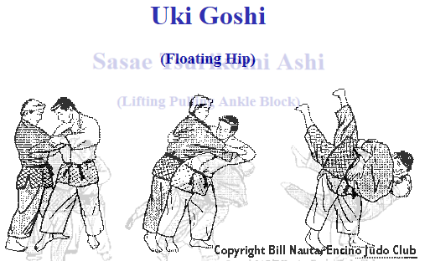
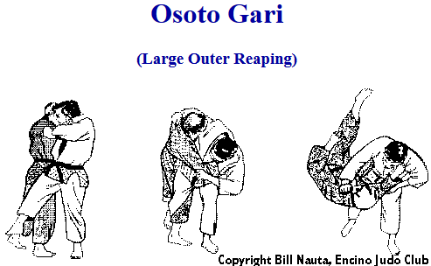 | 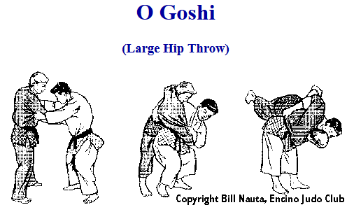
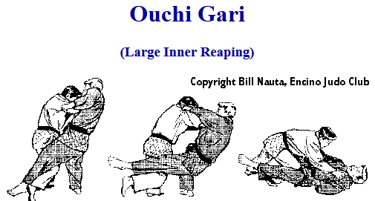 | 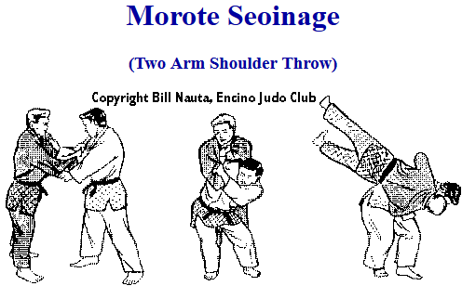

Dai Nikyo (2nd group)
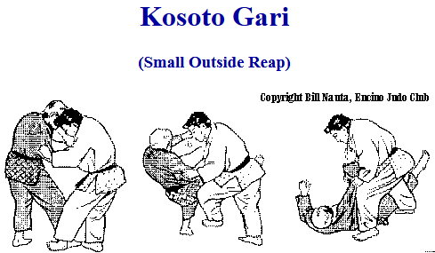 | 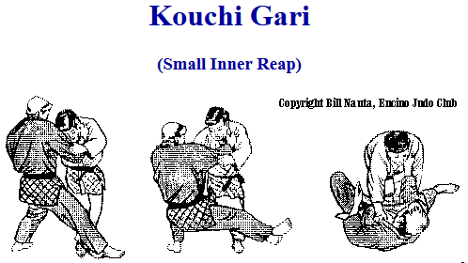
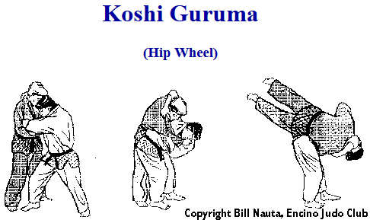 | 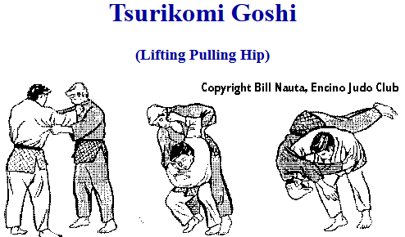
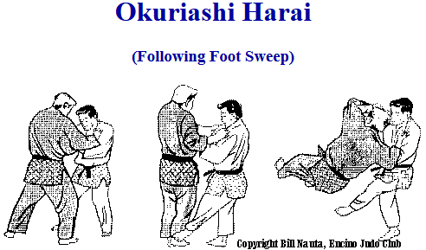 | 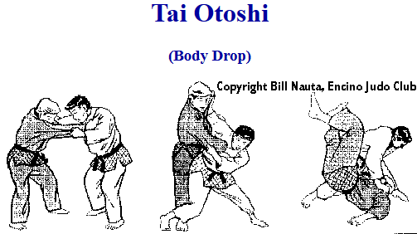
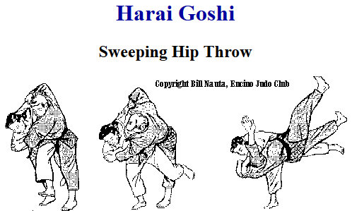 | 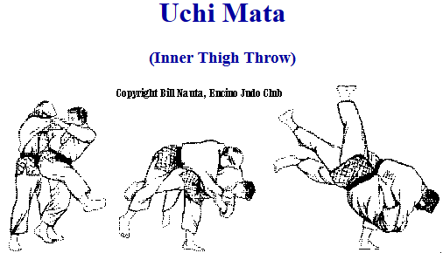

Sankyo (3rd group)
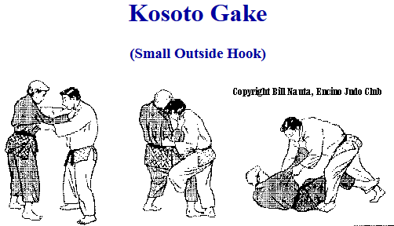 | 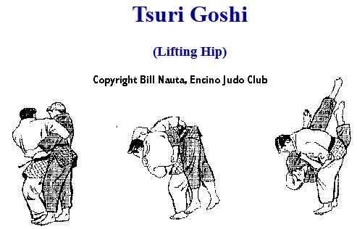
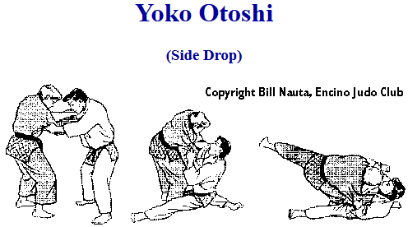 | 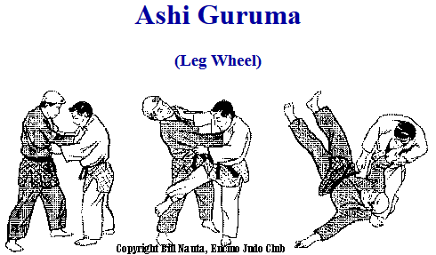
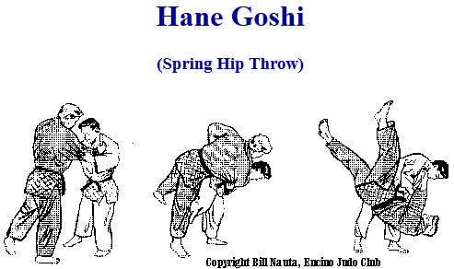 | 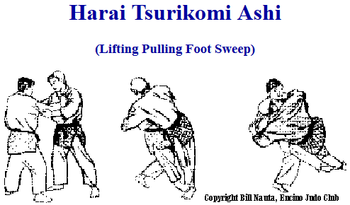
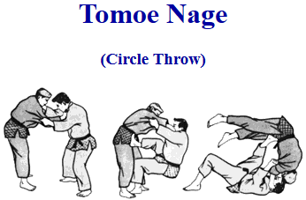 | 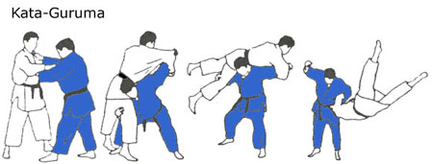

Yonkyo (4th group)
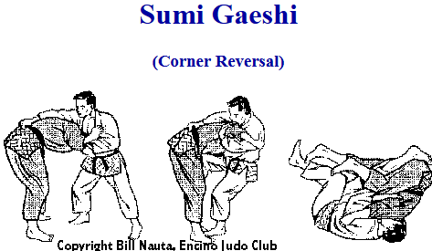 | 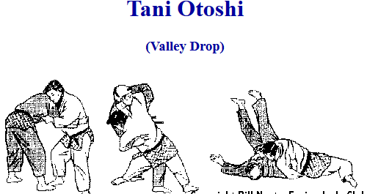
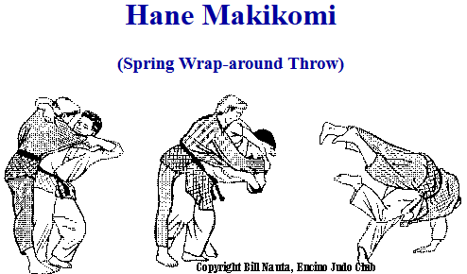 | 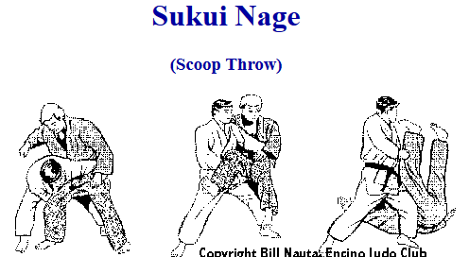
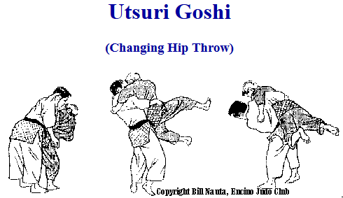 | 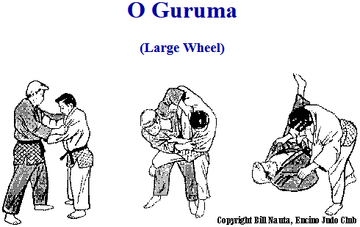
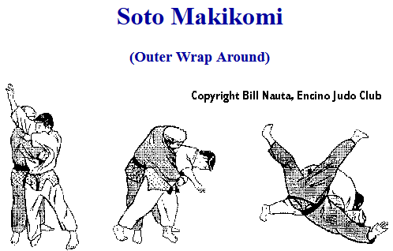 | 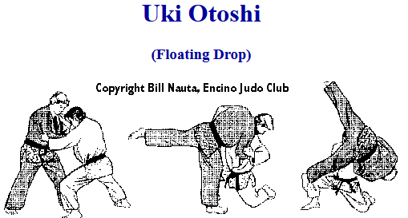

Gokyo (5th group)
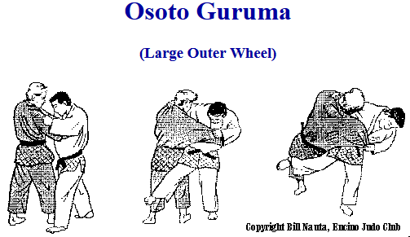 | 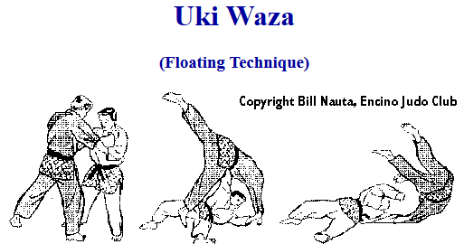
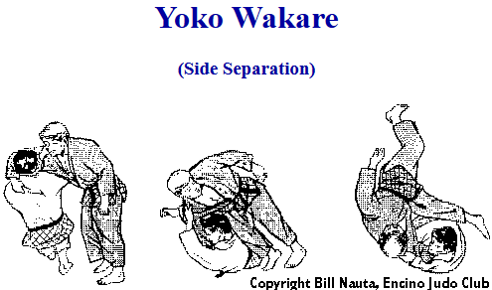 | 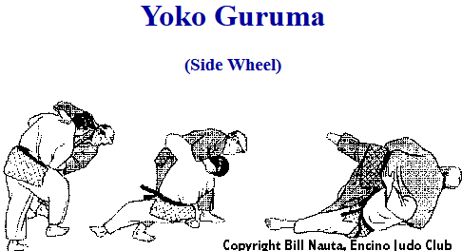
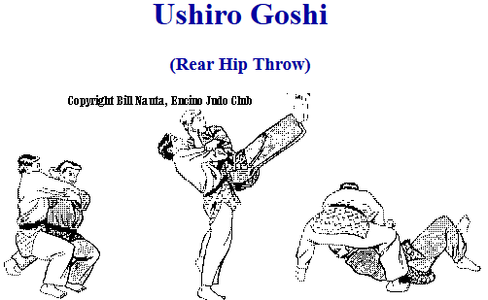 | 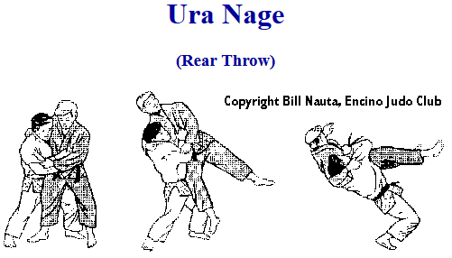
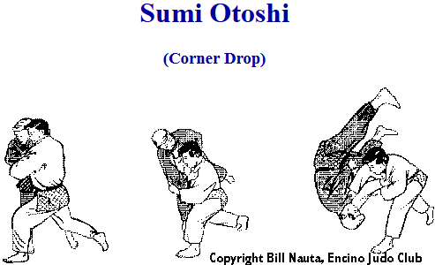 | 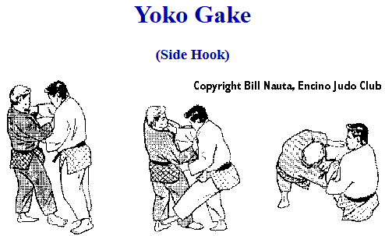

Habukareta Waza (preserved techniques from 1895 gokyo)

Obi Otoshi  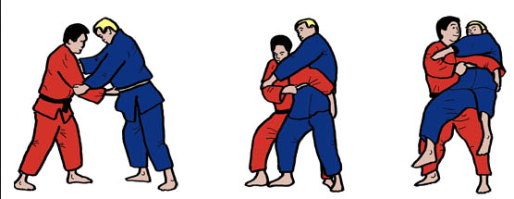 | Seo toshi Spread Legs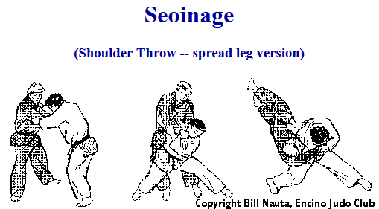
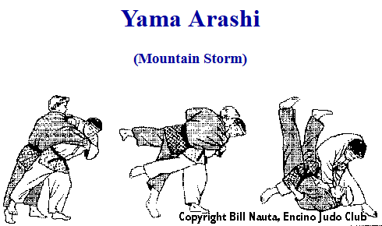 | 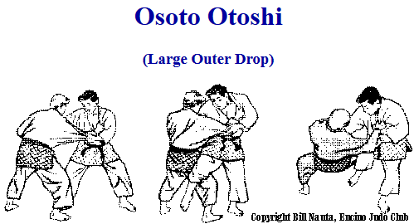
Daki Wakare (High Lift and Separate)  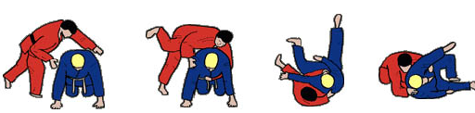 | Hikikomi Gaeish (Pulling In Reversal)  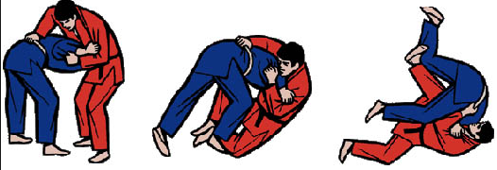
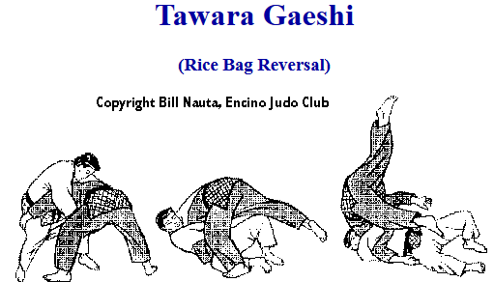 | Uschi Makikomi (Inner Wraparound Throw)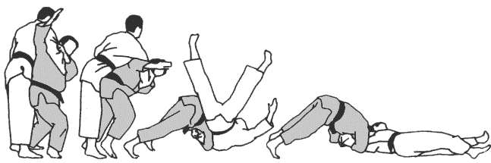

Shinmeisho No Waza (newly accepted techniques)

Morote Gari (Two Hand Reap)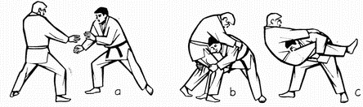 | Kuchiki Taochi (One Hand Drop)  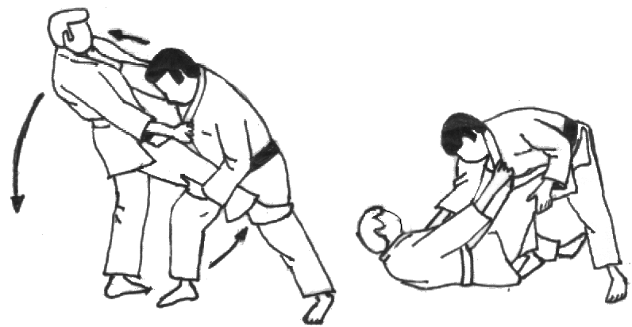
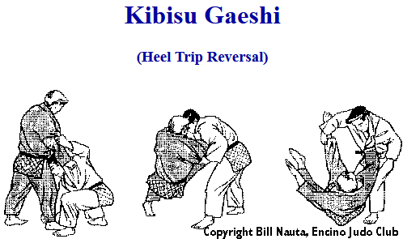 | Uchi Mata Sukashi (Kontring)  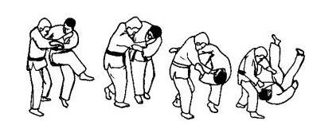
Daki Age (High Lift)  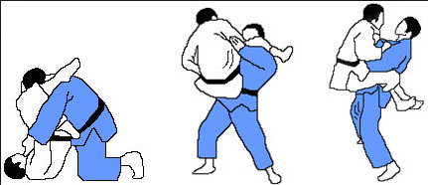 | Tsubame Gaeishi -kontring  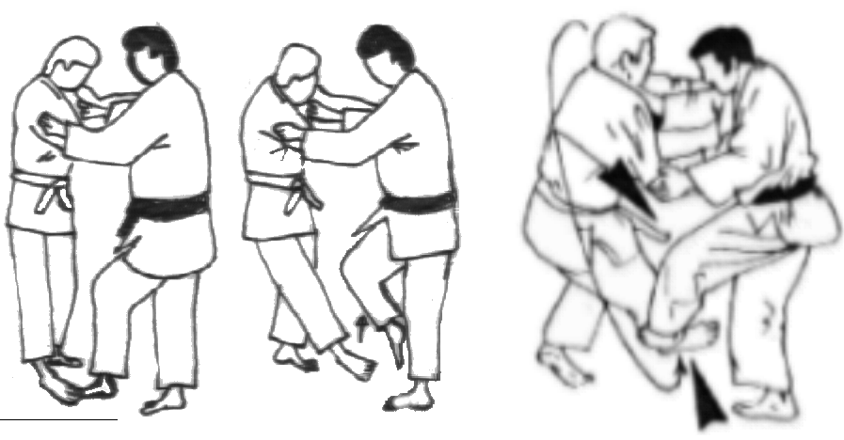
Kouchi Gaeishi (Minor Inner Reap Reversal) - Kontring  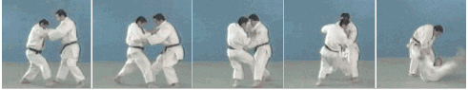 | Ouchi Gaeishi - Kontring  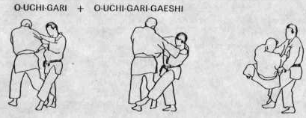
Osoto Gaeshi - Kontring  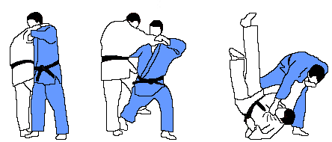 | Uchi Mata Gaeshi – Kontring  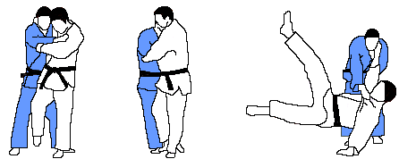
Harai Goshi Gaeishi - Kontring  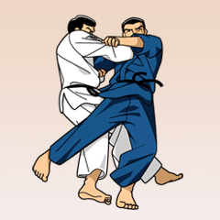 | Hane Goshi Gaeshi – Kontring  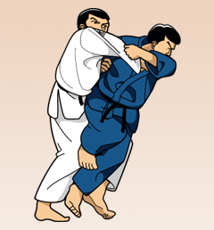
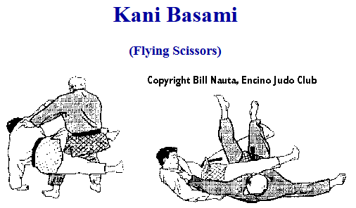 | 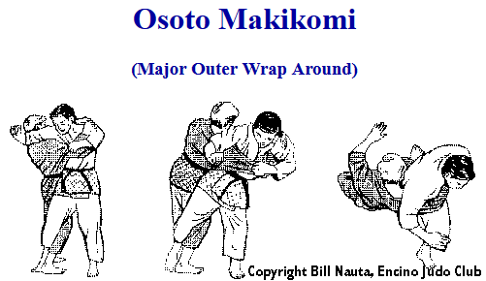
Kawatsu Gake  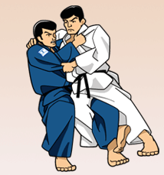 | Harai Makikomi  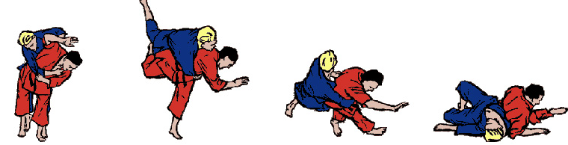
Uchi Mata Makikomi  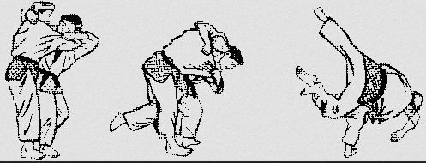 | 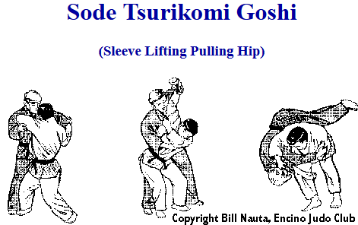
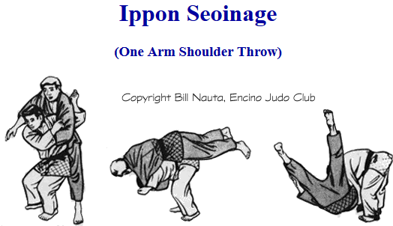

Osakomi wasa – Hold Downs
Kesa Gatame  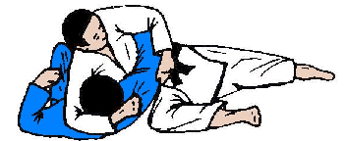 | Kuzure Kesa Gatame  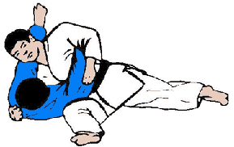
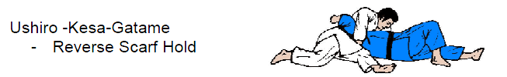
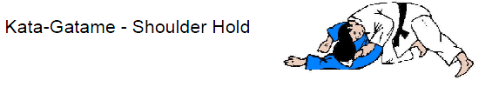
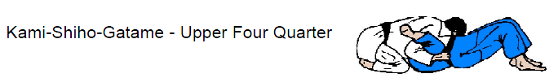
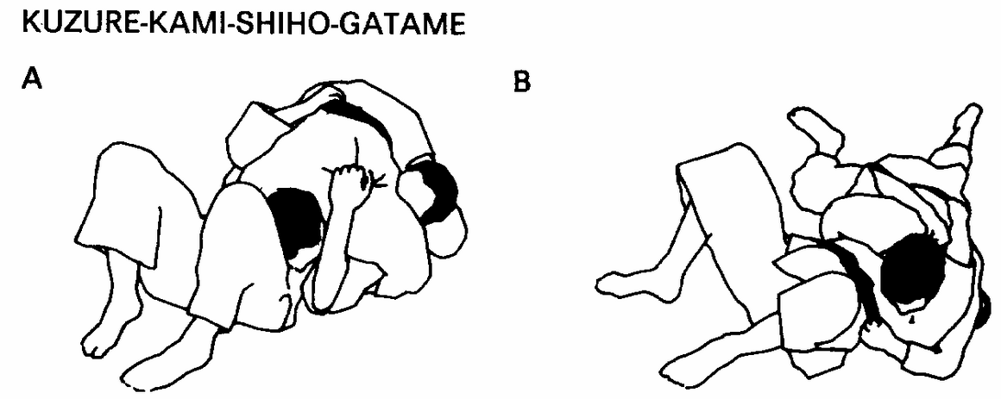
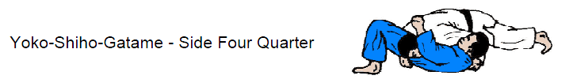
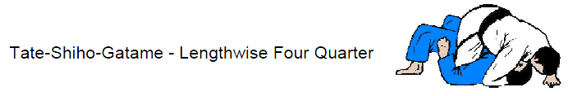
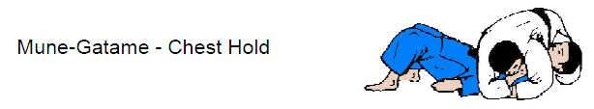

Kansetsu Wasa – Armlocks
Ude Garami  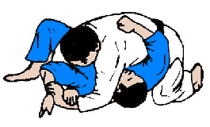 | ude-hishigi-juji-gatame  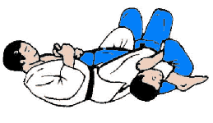
Ude-Hishigi-Ude-Gatame  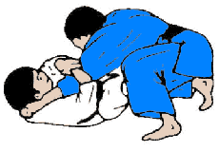 | ude-hishigi-hiza-gatame  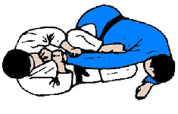
Ude-Hishigi-Waki-Gatame  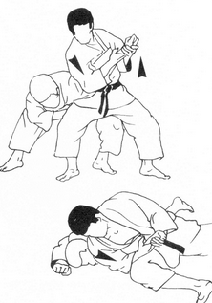 | Ude-Hishigi-Hara-Gatame  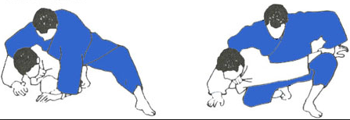
Ashi Garami  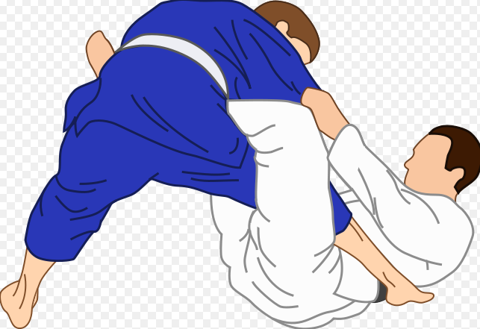 | Ude Hishigi Ashi Gatame  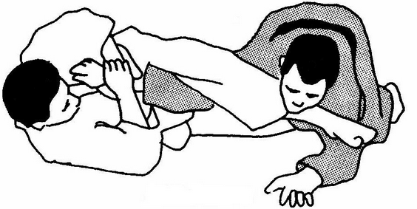
Ude Hishigi Te Gatame  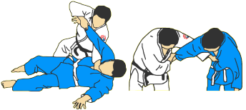 | Ude Hishigi Sankaku Gatame  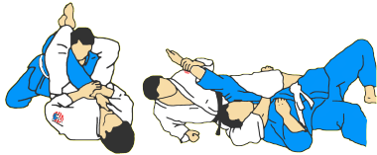

Shime Wasa
Nami-Juji-Jime (Normal Cross Strangle), Tummar innanför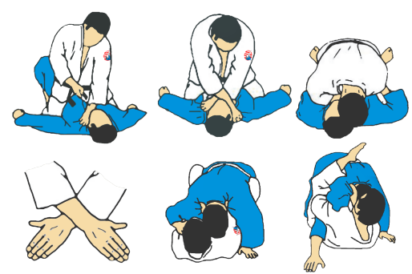 | Gyaku-Juji-Jime (Reverse Cross Strangle), Tummar utanför  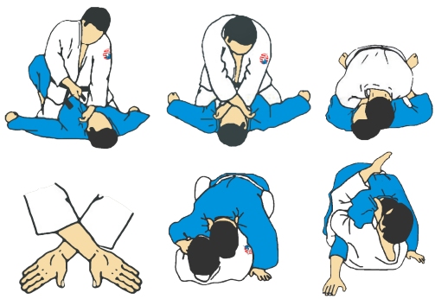
Kata-Juji-Jime (Half-Cross-Strangle) En tumme innanför & En utanför  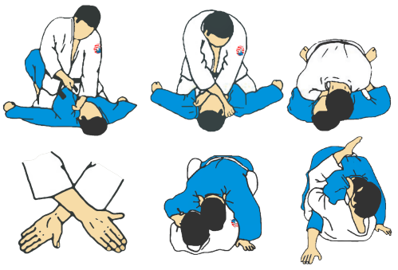 | Okuri – Eri – Jime (Sliding Collar Strangle)  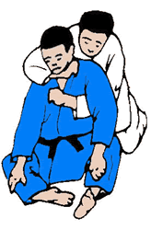
Sode-Guruma-Jime (Sleeve Wheel)  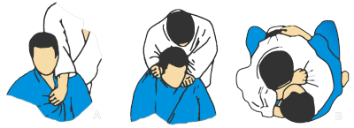 | Kata-Ha-Jima (Single Wing Strangle)  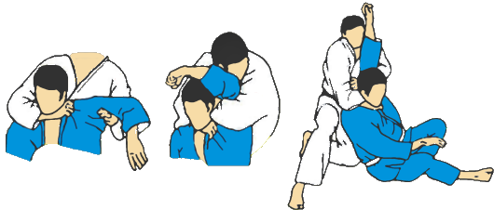
Sankaku-Jime (Triangulation Strangle)  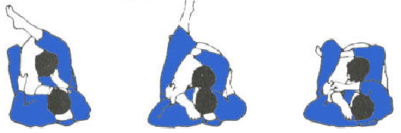 | Hadaka-Jime (Naked Strangle)  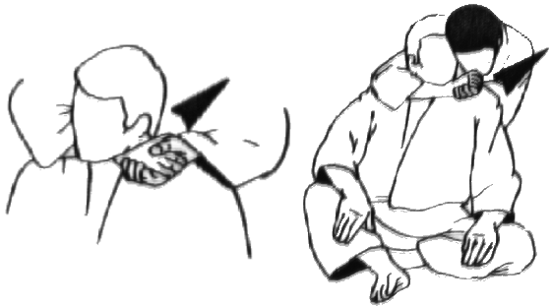
Kata-Te-Jime (One-Hand-Strangle)  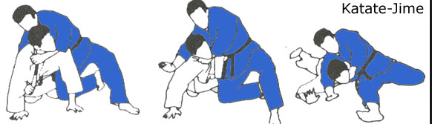 | Do-Jime (Body Strangle)  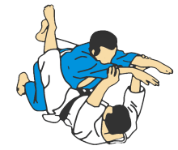
Tsukkomi-Jime (Thrusting Strangle) 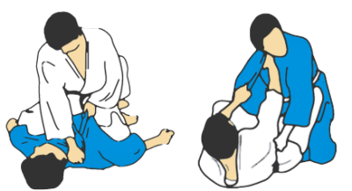 | Ryo-Te-Jime (Both Hand Strangle)  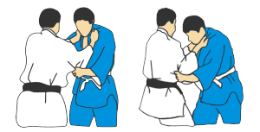

Nage-No-Kata, 1:a Serien , Te-Waza
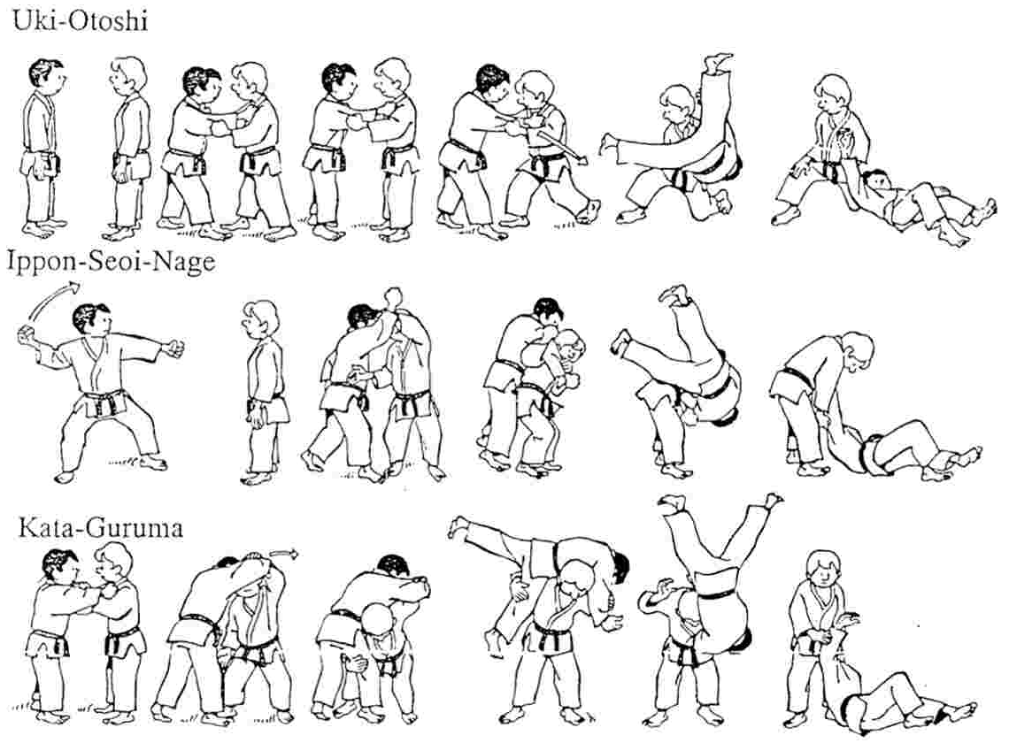

Nage-No-Kata, 2:a Serien, Koshi-Waza
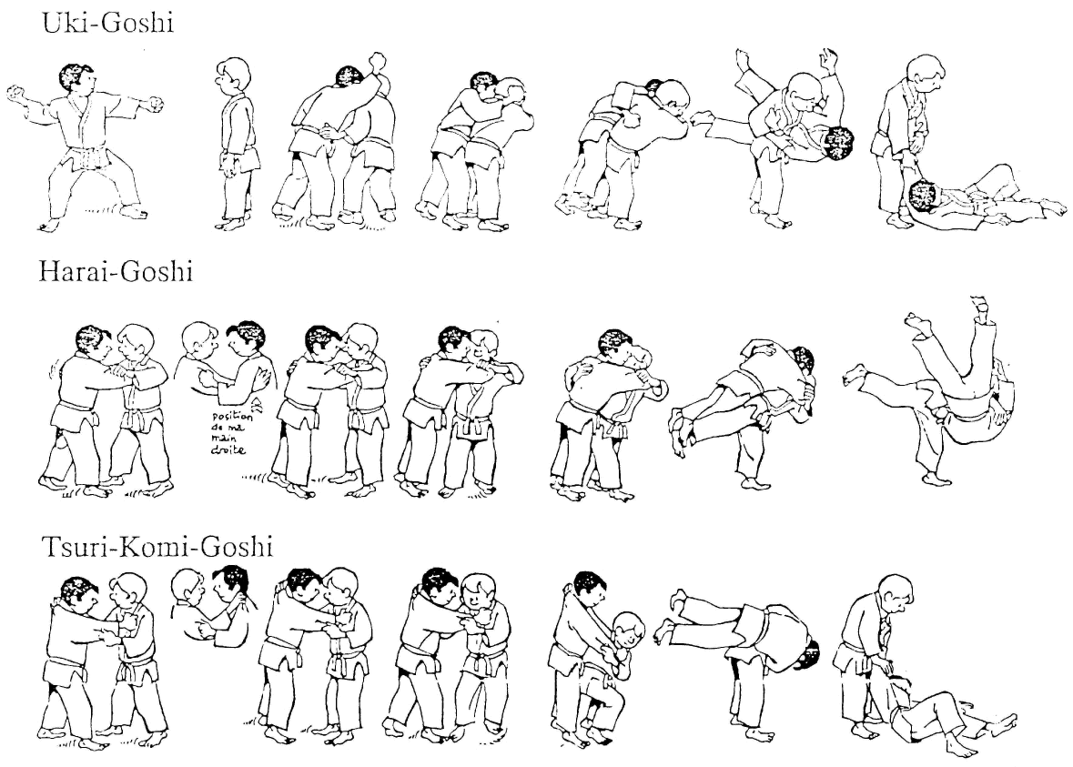

Nage-No-Kata, 3:e Serien, Ashi-Waza
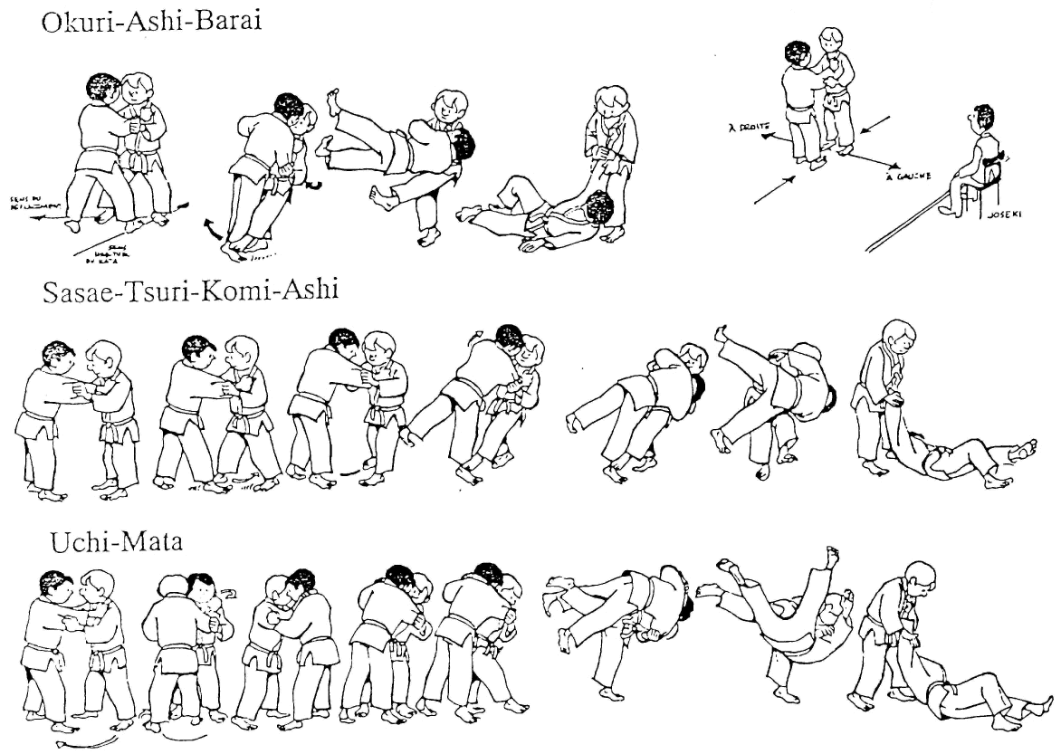

Nage-No-Kata,4:e Serien, Ma-Sutemi-Wasa
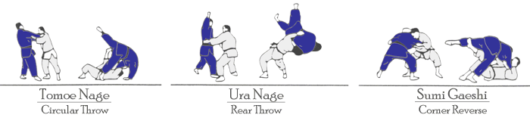

Nage-No-Kata,5:e Serien, Yoko-Sutemi-Wasa
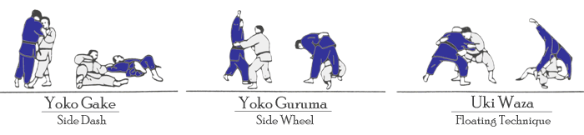

Ordlista
Arashi -> Storm  Ashi -> Fot  Atemi -> Slag  Do -> Väg  Gaeshi -> Motanfall  Gake -> Kroka, haka  Gari -> Liten svepning, meja  Gyaku -> Omvänd  Hajime -> Börja  Hara -> Nedre delen av buken  Hidari -> Vänster  Hishigi -> Bryta  Judo -> Den mjuka vägen  Judoka -> Judoutövare  Kaeshi waza -> Kontringsteknik  Kake -> Kast  Kannuki -> Regel, lås  Kansetsu waza -> Armlåsteknik  Kata -> Skuldra  Katame -> Fasthållning  Koshi -> Höft (goshi)  Kumi kata -> Greppteknik i Kuzure -> Variant  Kuzushi -> Balansbrytning  Mae ukemi -> Framåtfall  Maki komi waza -> Kastteknik där tori håller full kontakt ända ner i mattan  Masutemi waza -> Offerkast bakåt  Mate -> Bryt  Morote -> Tvåhands  Nage -> Kast  Nage waza -> Kastteknik  Ne waza -> Golvteknik  O -> Stor  Okuri -> Glida, två, par  Osae komi waza -> Fasthållningsteknik  Otoshi -> Falla  Rei -> Hälsning  Ritsurei -> Stående hälsning  Sabaki -> Vända bort, vrida  Sasae -> Låg blockering  Shizentai -> Naturlig ställning  Sode -> Ärm  Soremade -> Slut (tävling)  Sutemi -> Uppoffra  Tachi waza -> Stående teknik  Tani -> Dal  Tate -> Vertikal  Te kubi -> Handled  Tomoe -> Cirkel, hjul  Tsukuri -> Ingång  Uchi -> Insida, inre  Ude -> Arm  Ukemi waza -> Fallteknik  Ura -> Resa sig  Ushiro ukemi -> Bakåtfall  Utsuri -> Ändra, skifta  Waki -> Armhåla  Yoko -> Sida  Yoko sutemi waza -> Offerkast åt sidan  Yoshi -> Starta, Sätt igång | Age -> Lyfta upp  Arigato -> Tack  Ashi kubi -> Fotled  Atemi waza -> Slag teknik  Awasete -> Sammanlagt  Barai -> Stort svep i sidled, sopa bort  De -> Föra framåt  Eri -> Slag (på judogin)  Gaeshi waza -> Motkast tekniker  Garami -> Böja, vrida, fläta  Gatame -> Fasthålla (katame)  Goshi -> Höft  Guruma -> Hjul, sväng  Hadaka -> Naken  Hane -> Vinge  Harai -> Svep  Hiji -> Armbåge  Hikomi waza -> Övergångsteknik från tachi waza till ne waza  Hiza -> Knä  Jigotai -> Försvarsställning i judo  Jime -> Strypa (shime)  Ju -> Mjuk  Juji -> Kors, över  Kagato -> Häl  Kami -> Hög ovanför  Kansetsu -> Led, knoge  Kata -> Form "arrangerad judo"  Kesa -> Krage, slag  Ko -> Liten  Koho ukemi -> Bakåtfall  Komi -> Dra intill  Kubi -> Nacke  Kusushi waza -> Balansbrytningsteknik  Mae -> Framsida, framåt  Maki -> Rulla in, vrida  Mata -> Lår  Migi -> Höger  Mune -> Bröstkorg  Nage no kata -> Kasttekniksform  Obi -> Bälte  Osae -> Hålla, trycka  Oshi -> Knuffa  Randori -> Fri övning träning  Renraku waza -> Kombinationsteknik  Ryote -> Tvåhands  Sankaku -> Triangel  Seoi -> Skuldra, ta upp på ryggen  Shime waza -> Halslåsteknik  Shizen hontai -> Grundställning/hållning  Soto -> Utsida  Sumi -> Hörn  Sutemi waza -> Offerkastteknik  Tai -> Kropp  Te -> Hand, arm  Te waza -> Handkastteknik  Tokui waza -> Favoritteknik  Tori -> Den som utför tekniken  Tsukkomi jime -> Frånskjutet halslås  Tsuri -> Lyfta  Uchi komi -> Upprepningsträning  Uke -> Den som tekniken blir utförd på  Uki -> Flyta, flyga  Ushiro -> Bakåt  Wakare -> Dra, rycka  Waza -> Teknik  Yaku soku geiko -> Kast varannan gång i rörelse  Yoko ukemi -> Sidofall  Yubi -> Fingrar  Zempo -> Framåt

